Parth Babbar

Biometric authentication systems

Introduction:
Biometric identification technologies have become standard in US banking, providing strong security by validating identity using unique biological attributes rather than traditional techniques such as passwords or PINs. This method improves both security and the user experience. This presentation examines the acceptance, advantages, problems, data, and solutions for biometric authentication systems in the US banking sector.
Adoption and Implementation:
Biometric authentication technologies have been more popular among US banks due to their efficiency in improving security and consumer comfort. Fingerprint recognition, face recognition, iris scanning, voice recognition, and behavioural biometrics such as typing patterns are among the most often employed.
- Fingerprint Scanning: Using distinct ridges and valleys on fingers.
- Facial Recognition: Analysing facial characteristics to confirm identification.
- Vocal Recognition: The process of identifying persons based on their vocal patterns.
- Iris and Retinal Scanning: Using distinct patterns in the eye.
Applications in Banking:
- Mobile Banking: Unlocking banking applications with fingerprints or face recognition.
- ATMs: Adding biometric authentication to ATM transactions.
- Branch Services: Improved security for in-branch transactions and services.
Benefits:
- Enhanced Security: Biometrics offer a more secure method of authentication than passwords or PINs, which are readily exploited.
- Convenience: Customers prefer biometric authentication because it is faster and more comfortable than remembering several passwords or carrying physical tokens.
- Decreased Fraud: Biometrics may considerably reduce fraud incidences such as identity theft and unlawful access.
Challenges:
- Privacy issues: The collection and storage of biometric data generates privacy issues among customers and regulatory agencies.
- Accuracy and Reliability: Biometric systems might make mistakes owing to variables like low picture quality (for facial or iris identification) or environmental conditions (for fingerprint scanning).
- Cost of Implementation: Integrating biometric technology into existing financial infrastructure can be costly, especially for smaller institutions.
Solutions:
- Privacy Protection: To safeguard biometric data, banks must follow severe data protection standards (e.g., GDPR, CCPA) and use powerful encryption mechanisms.
- Enhanced Technology: Continuous advancements in biometric technology offer greater accuracy and dependability, resolving concerns regarding false positives and negatives.
- Cost Efficiency: Cloud-based biometric solutions and collaborations with technology suppliers can assist smaller banks reduce initial installation costs.
Statistics:
- According to a Juniper Research poll conducted in 2023, 68% of US banks use biometric authentication.
- Biometric authentication in banking is predicted to reach $9 billion by 2026, with global growth from $42.9 billion in 2022 to $82.9 billion in 2027.
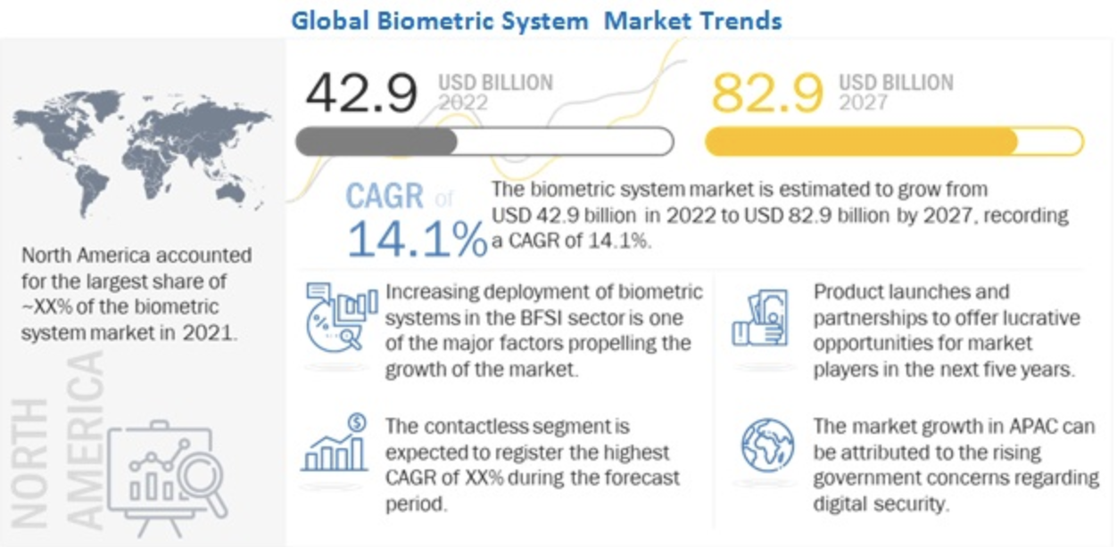
- FICO's 2023 poll indicated that 72% of US customers are comfortable utilizing biometric authentication for banking services.
Conclusion:
Biometric authentication systems are a key improvement in US banking security, providing better fraud prevention while also boosting consumer happiness. While privacy concerns and implementation costs remain, continuous technical developments and regulatory compliance initiatives are expected to fuel further adoption throughout the sector.

